
Company
Logotype

Cone Beam Computed Tomography- Report



Porur Dental X-rays & CBCT

Patient Name : Mrs. Sampoornam | Date of Report : 22. 07. 2024
Age/ Gender : 45 years/ Female | Region of Interest : CBCT Full Skull
Referring doctor: Dr. Anand Kumar | Indication : Implant assessment
Clinical Notes: Nil
PATIENT INFORMATION

CBCT- Full Skull provided
CBCT – IMAGE DETAILS

RADIOGRAPHIC INTERPRETATION

- Completely missing crown and root structure in relation to 18, 25, 26, 37, 46, 47, 48 evident.
- Root stumps in relation to 13, 15, 16, 27, 28, 34, 35, 36, 38, 44, 45 evident.
- The alveolar ridge in relation to the maxillary and mandibular alveolar ridge is present with normal trabecular pattern.

IMPLANT ASSESSMENT

 | 11 region | 12 region | 13 region | 14 region | 21 region | 22 region | 23 region | 24 region
Sub-Crestal | 14.7 | 3.6 | 4.1 | 6.5 | 3.3 | 1.7 | 3.6 | 6.2
Mid- Crestal | 3.6 | 3.2 | 5 | 5.9 | 2 | 2.4 | 3.5 | 5.2
Distance between the alveolar ridge and Floor of the Nasal cavity (in mm) | 3.6 | 14.4 | 15.6 | 16 | 16.6 | 15.8 | 12.6 | 11.8

 | 15 region | 16 region | 17 region | 25 region | 26 region | 27 region
Sub-Crestal (in mm) | 8.8 | 10.4 | 13.2 | 7.2 | 7.3 | 8.1
Mid- Crestal (in mm) | 7.6 | 10.4 | 15.5 | 8 | 9 | 10.9
Distance between the alveolar ridge and floor of the maxillary sinus (in mm) | 14..7 | 7.4 | 8.5 | 19.3 | 14.7 | 13.8

 | 31 region | 32 region | 33 region | 34 region
Sub-Crestal (in mm) | 2.8 | 3.2 | 6.7 | 6.6
Mid- Crestal (in mm) | 3.9 | 4.2 | 6.5 | 6.1
Distance between alveolar ridge and the inferior border of mandible (in mm) | 26.8 | 24.8 | 19.1 | 20.8

 | 41 region | 42 region | 43 region | 44 region
Sub-Crestal (in mm) | 3.6 | 4.3 | 5.6 | 5.4
Mid- Crestal (in mm) | 3.9 | 3.5 | 4.8 | 5.8
Distance between alveolar ridge and the inferior border of mandible (in mm) | 25.9 | 24.1 | 24.6 | 26.6
 | 45 region | 46 region | 47 region
Sub-Crestal (in mm) | 7.7 | 6.8 | 5.9
Mid- Crestal (in mm) | 8.8 | 10.2 | 9.1
Distance between alveolar ridge and the inferior alveolar nerve canal (in mm) | 14.6 | 17.8 | 15.6
Distance between alveolar ridge and the inferior border of mandible (in mm) | 28 | 28.1 | 26.6

 | 35 region | 36 region | 37 region
Sub-Crestal (in mm) | 4.6 | 8.1 | 5.1
Mid- Crestal (in mm) | 4.4 | 8.8 | 6.5
Distance between alveolar ridge and the inferior alveolar nerve canal (in mm) | 15.1 | 13.6 | 16.2
Distance between alveolar ridge and the inferior border of mandible (in mm) | 28 | 25.3 | 28.7

RADIOGRAPHIC IMPRESSION

- Partially edentulous maxillary and mandibular arch.
- Root stumps in relation to 13, 15, 16, 27, 28, 34, 35, 36, 38, 44, 45.

Kindly correlate with clinical findings


IMAGES FOR REFERENCE

RECONSTRUCTED PANORAMIC VIEW

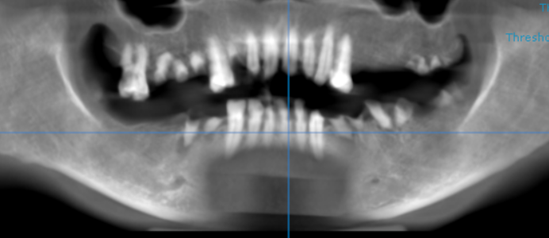

3-DIMENSIONAL VIEW

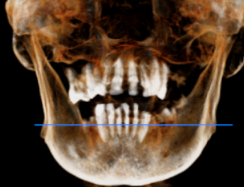

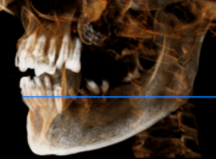
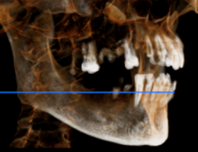

CROSS SECTIONAL VIEW

11 region | 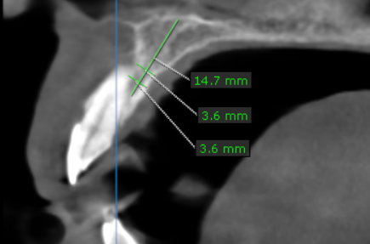
12 region | 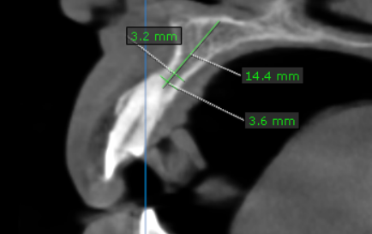
13 region | 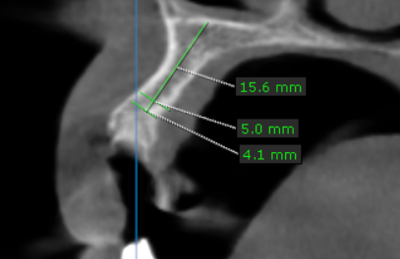
14 region | 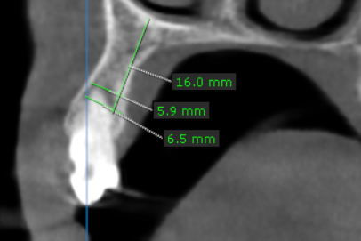
15 region | 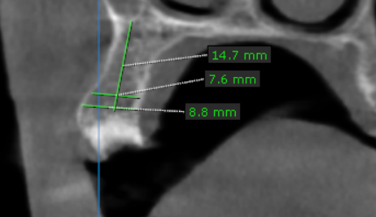
16 region | 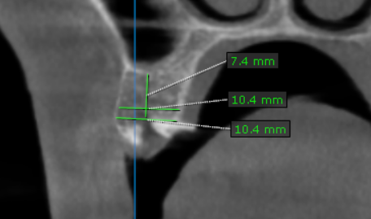
17 region | 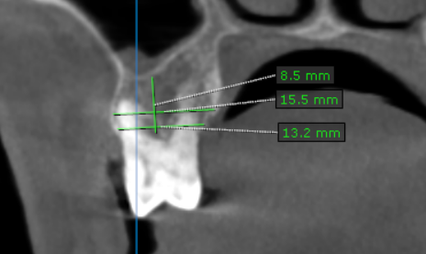
21 region | 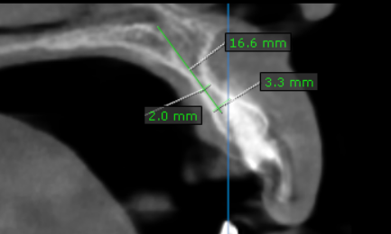
22 region | 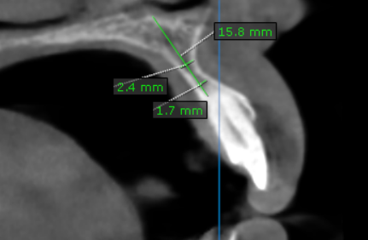
23 region | 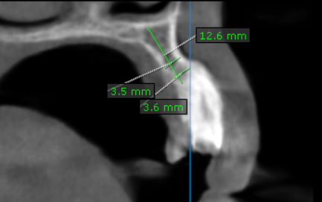
24 region | 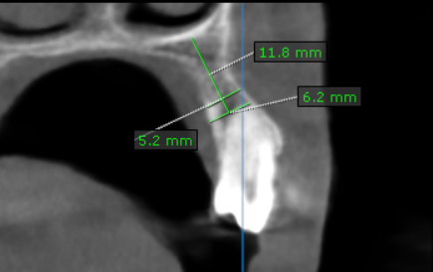
25 region | 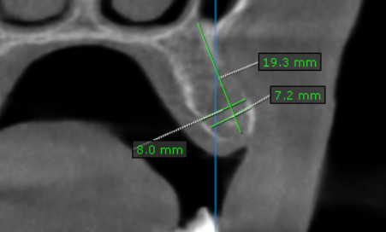
26 region | 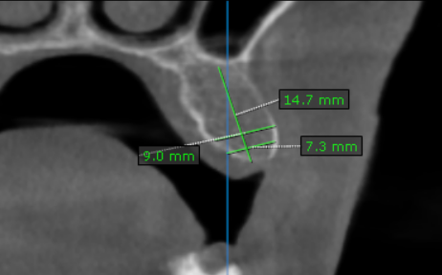
27 region | 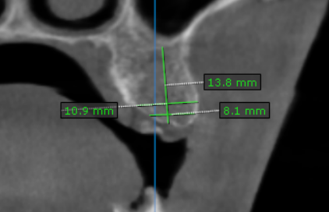
31 region | 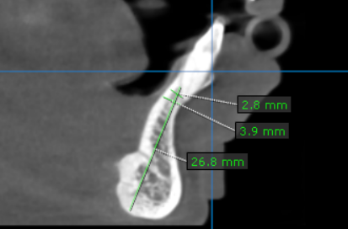
32 region | 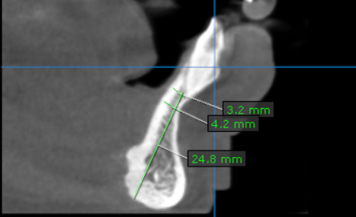
33 region | 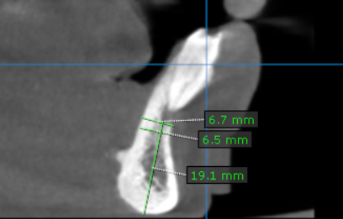
34 region | 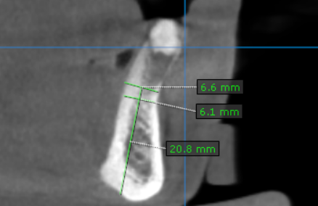
35 region | 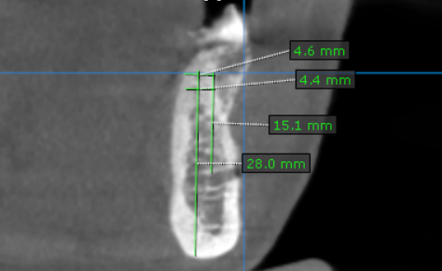
36 region | 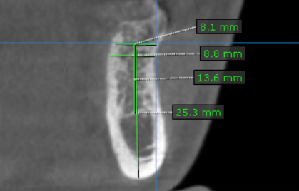
37 region | 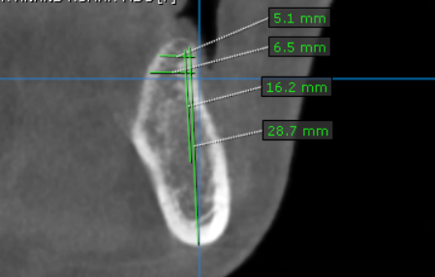
41 region | 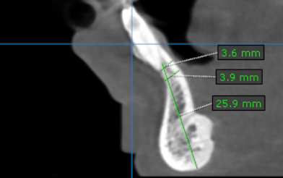
42 region | 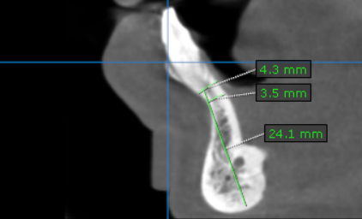
43 region | 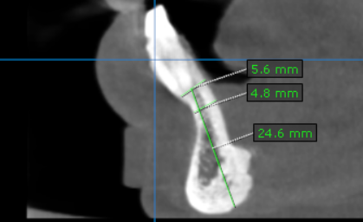
44 region | 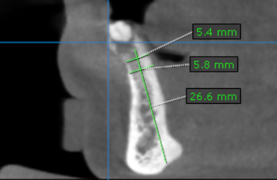
45 region | 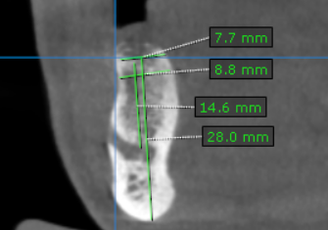
46 region | 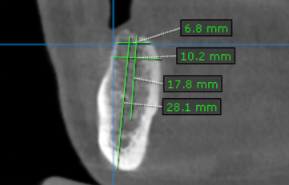
47 region | 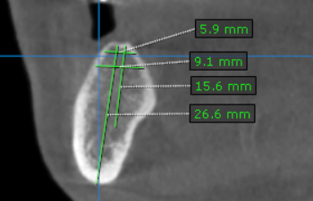

**** End of report ****

